Mechanical Engineering
ME 481

Vehicle Design

Fall 2000

Lecture Notes

By

Richard B. Hathaway, Ph.D., PE

Professor

Mechanical and Aeronautical Engineering

Section 1
Energy Consumption
and
Power Requirements in Design

Aerodynamics and Rolling Resistance

GENERAL FORMULAS - AERODYNAMIC

Dynamic Pressure:
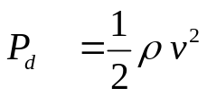

Drag Force:
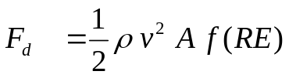
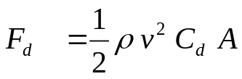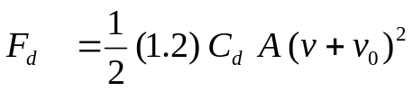

Aero Power
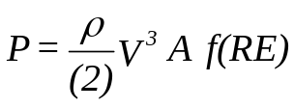
C_{d} = coefficient of drag ρ = air density ≈ 1.2 kg/m³
A = projected frontal area (m²) f(RE) = Reynolds number
v = vehicle velocity (m/sec) V₀ = headwind velocity

ENGLISH UNITS

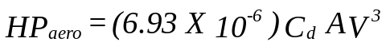

where: A = area (ft²) V = velocity (MPH) C_{d} = drag coefficient

SI UNITS

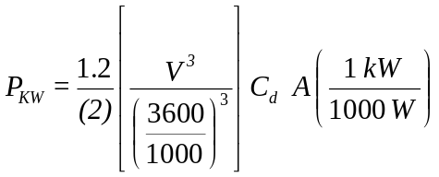

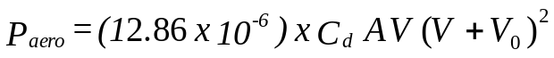

P = power (kw) A = area (m²)
V = velocity (KpH) V₀ = headwind velocity
C_{d} = drag coefficient ρ = 1.2 kg/m³

GENERAL FORMULAS – ROLLING RESISTANCE

ENGLISH UNITS

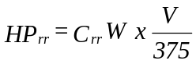
where: C_{rr} = coefficient of rolling resistance W = weight (lbs) V = velocity (MPH)

SI UNITS

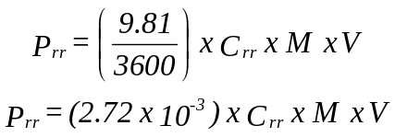

where: P = power (kw) C_{rr} = coefficient of rolling resistance
M = mass (kg) V = velocity (KpH)

TRACTIVE FORCE REQUIREMENTS.

Vehicles require thrust forces, generated at the tires, to initiate and maintain motion. These forces are usually referred to as tractive forces or the tractive force requirement. If the required tractive force (F) is broken into components the major components of the resisting forces to motion are comprised of acceleration forces (F_{accel} = ma & Iα forces), Gradeability requirements (F_{grade}), Aerodynamic loads (F_{aero}) and chassis losses (F_{roll resist} ).

F = F_{aero} + F_{roll resist} + F_{grade} + F_{accel}

= (ρ/2) C_{d} A v² + C_{rr} m g + %slope m*g + m a

= (ρ/2) C_{d} A v² + m g{C_{rr} + % slope + a/g}

in SI units:
A = frontal area (m²) v = velocity (m/s) m = mass (kg)
C_{rr} = coefficient of roll resistance (N/N) usually approx .015
C_{d} = coefficient of aero drag for most cars .3 - .6
% slope = Rise/Run = Tan of the roadway inclination angle

Steady state force are equal to the summation of F_{aero} + F_{roll resist} + F_{grade}

Transient forces are primarily comprised of acceleration related forces where a change in velocity is required. These include the rotational inertia requirements (F_{Iα} ) and the translational mass (F_{ma}) requirements, including steady state acceleration.

VEHICLE ENERGY REQUIREMENTS.

The energy consumption of a vehicle is based on the tractive forces required, the mechanical efficiency of the drive train system, the efficiency of the energy conversion device and the efficiency of the storage system. Examples of the above might best be demonstrated with the following.

Storage efficiency:
A flywheel used for energy storage will eventually lose its total energy stored due to bearing and aerodynamic losses. A storage battery may eventually discharge due to intrinsic losses in the storage device. These losses can be a function of the % of the total system capacity at which the system is currently operating. A liquid fuel usually has extremely high storage efficiency while a flywheel may have considerably les storage efficiency. Both however have the storage efficiency a function of time.

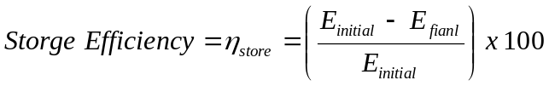

Conversion efficiency:
An internal combustion engine changes chemical energy to mechanical energy. The system also produces unwanted heat and due to moving parts has internal friction which further reduces the system efficiency. A storage battery has an efficiency loss during the discharge cycle and an efficiency loss during the charge cycle. These efficiencies may be a function of the rate at which the power is extracted.
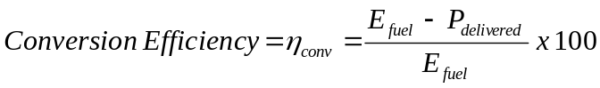
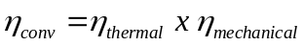

Drive system Efficiency:
Conversion of chemical or electrical to mechanical energy does not complete the power flow to the wheels. Drive train inefficiencies further reduce the power available to produce the tractive forces. These losses are typically a function of the system design and the torque being delivered through the system.

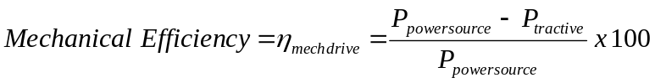

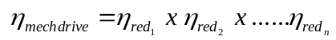

Reasonable Efficiencies to use for cycle comparisons

(Efficiencies shown are only approximations)

- Electric Motor (Peak) η = 95%

- Electric Motor Efficiency (Avg if 1 spd Trans) η = 75%

- Electric Motor Efficiency (Avg if CVT) η = 95%

- Transmission Efficiency 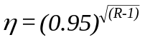

- Battery Efficiency (Regen) η = 75-85%

Battery & Generator Efficiency (Regen) η = 50-55%

- Battery & Motor Efficiency (Accel) η = 80%

- Solar Cell Efficiency η = 15%

- IC Engine (Peak Efficiency) η = 30%

Flywheel Efficiency

(Storage and Conversion Average) η = 70%

Experimental Coast Down Testing

- Perform a high speed and a low speed test with an incremental (≈ 5km/hr) velocity change at each velocity.

High Speed Low Speed
V_{a1} = 60 km/h V_{a2} = 20 km/h

V_{b1} = 55 km/h V_{b2} = 15 km/h

- Record the times over which the velocity increments occur.

T_{h} = 4 sec T_{l} = 6 sec

- Determine the mean speed at each velocity.
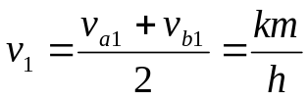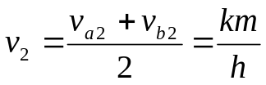

- Determine the mean deceleration at each velocity.

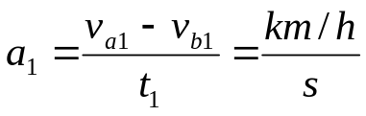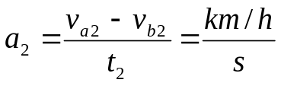

- Determine the drag coefficient
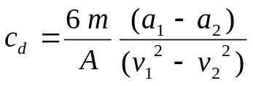

- Determine the coefficient of rolling resistance.

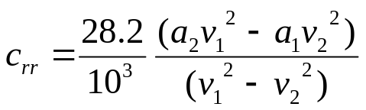

Section 2

Weight and Weight Factors in Design

WEIGHT and ROTATIONAL INERITA EFFECTS:

Thrust force (F), at the tire footprint, required for vehicle motion:

F = F_{aero} + F_{roll resist} + F_{grade} + F_{accel} = (ρ/2) C_{d} A v² + C_{rr} m g + %slope m*g + m a

F = (ρ/2) C_{d} A v² + m g{C_{rr} + % slope + a/g}

in SI units:
A = frontal area (m²) v = velocity (m/s) m = mass (kg)
C_{rr} = coefficient of roll resistance (N/N) usually approx .015
C_{d} = coefficient of aero drag for most cars .3 - .6
% slope = Rise/Run = Tan of the roadway inclination angle

If rotational mass is added it adds not only rotational inertia but also translational inertia.
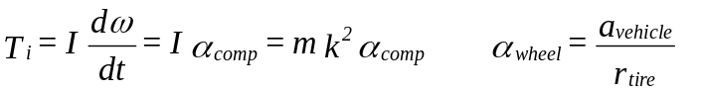

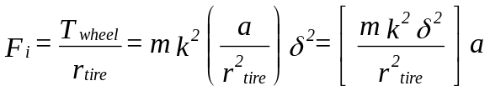

α = angular acceleration k = radius of gyration t = time T = Torque m = mass δ = ratio between rotating component and the tire

Therefore if the mass rotates on a vehicle which has translation,
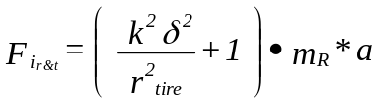

F = F_{aero} + F_{roll resist} + F_{grade} + F_{accel} = (ρ/2) C_{d} A v² + C_{rr} W_{t} + %slope W_{t} + W_{t} a/g

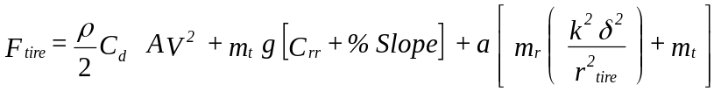

ω = angular velocity of the component T_{i} = applied torque to overcome inertia
I = mass moment of inertia α_{wheel} = angular acceleration of the wheel
a = translational acceleration of the vehicle
r_{tire} = rolling radius of the tire (meters) T_{wheel} = applied torque at the wheel
F_{i} = tractive force at the tire footprint to overcome inertia
F_{i(r&t)} = tractive force at the tire footprint required for losses and translational and rotational inertia

The PowerPlant Torque is:
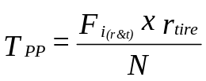

The speed of the vehicle in km/h is:
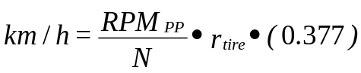

r_{tire} = Tire Rolling Radius (meters) N = Numerical Ratio between P.P. and Tire

WEIGHT PROPAGATION

It might simply be said that weight begets weight in any design!

- Nearly all vehicle systems are affected by a change in weight of any one component.

- Power increases and/or performance decreases are associated with weight increases.

- “Rule of Thumb” approximations can be made to predict the effects of weight increases.

For alternate power systems (considering the power system as a unit)

ΔW due to weight = 22% x total weight increment

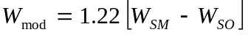

ΔW due to power increase = 4.5% x total weight x power increment

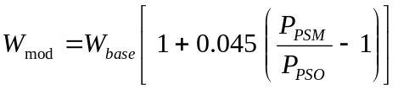

Combining the above factors into a single equation:
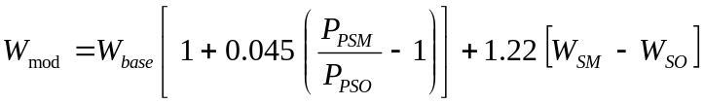

Section 3
Power Train Systems and Efficiencies

ENERGY STORAGE in VEHICLES

I. LIQUID FUELS (Heat Energy)
- Fossil
- Non-Fossil (Alcohol)

II. GASEOUS FUELS (Heat Energy)
- Fossil (largely)
- Non-Fossil Hydrogen

III. FLYWHEELS (Kinetic Energy)
- Mechanical
IV. HYDRAULIC (Potential Energy)
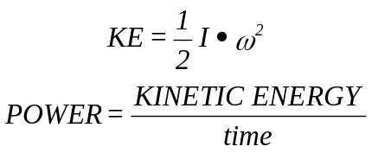

- Accumulator (Pressure, Volume)

POWER = Q x P

V. BATTERY (Electrical Energy)
- Generator recharging
- Solar Recharging

ENERGY CONVERSION

I. INTERNAL COMBUSTION ENGINES:
- Otto cycle
- Diesel cycle
- Brayton cycle

II. EXTERNAL COMBUSTION ENGINES:
- Stirling cycle

Rankine cycle

III. MECHANICAL:
- Flywheel
- Hydraulic motors

IV. ELECTRIC:
- Electric motors

ENERGY STORAGE

I. LIQUID FUELS:
+ Long Term Storage Possible
+ High Energy / Weight (Fuel & System)
+ High Energy / Volume

- Relatively Low Energy Conversion Ratio
- many are Fossil Fuels => Finite Supply
- Impractical to Recover / Regenerate
- High Atmospheric Pollution

II. GASEOUS FUELS:
+ Long Term Storage Possible
+ High Energy / Weight (fuel)

- Low Energy / Weight (system)
- Impractical to Recover / Regenerate
- Relatively Low Energy Conversion Ratio
- Relatively High Atmospheric Pollution

III. FLYWHEEL:
+ High Energy Conversion Ratio
+ High Transient Regeneration Possible
+ Total on-demand Energy Conversion
+ Zero Atmospheric Pollution

- Relatively Short Storage
- Influences Vehicle Dynamic Behavior

IV. HYDRAULIC:
+ Long Term Storage Possible
+ High Energy / Weight (storage)
+ High Transient Regeneration Possible
+ High Energy Conversion Ratio
+ Total on-demand Energy Conversion
+ Zero Atmospheric Pollution

- Complexity, Bulk, Noise

V. Battery:
+ Recharge w/o Fossil Fuels
+ Total on-demand Energy Conversion
+ Limited Atmospheric Pollution

- Finite Storage Life
- Low Energy / Weight
- Low Energy / Volume
- Low Energy Conversion Ratio

Hybrid Vehicles Power System Matching

PROBLEM:
I. The various power systems provide torque and power curves which are considerably different in shape.

II. The different power systems peak in efficiency at different speeds in their operating range.

III. The different power systems peak in efficiency at different loads-speed points.

In Light of I, II, and III above a method must be devised to optimize or maximize:

1. Torque Output

2. Peak Efficiency

3. Transition from one Power System to the other
or
Phasing in of the Second Power System in a Parallel System.

A STRATEGY MUST BE DEVISED TO PROVIDE PROPER TIMING OF EACH SYSTEM BASED ON:

a. Demand

b. Efficiency

c. Perception of the operator

d. System State
- Total Energy Reserve
- Total System Capacity
- Energy Required for Completion of Mission

e. Energy State of each Individual System

Gearbox: Transmission

- Manual transmission:
The types of manual transmission are:
- Sliding mesh type
- Constant mesh type
- Synchromesh gear box

The various components of a manual gearbox and their respective design considerations are listed:

Design considerations for shaft:
There are 3 shafts in the gearbox, namely: Input or clutch shaft, Intermediate or lay shaft and Output or main shaft.

- Input or clutch shaft:
Design consideration:
Shear and torsional stresses as well as the amount of deflection under full load. This should not only be designed for maximum engine torque, but also for absorbing torques as high as five times the maximum engine torque which can be generated by ‘clutch snapping’ in the lower gear.

- Intermediate or lay shaft:
Design consideration:
Shear and torsional stresses should be calculated. Amount of deflection should be calculated using the load on the internal gear pair, which is nearest to the half way between the intermediate shaft mounting bearings. For shafts with splines and serrations, it is common to use the root diameter as the outside diameter in the stress calculations.

- Output or main shaft:
Design consideration:
Shear and torsional stresses should be calculated.

General equations:
- Maximum shear stress for shaft, f_{s} for a solid circular shaft:
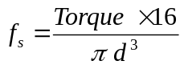 where, d = diameter of shaft Torque in lb-in

2. Amount of deflection:
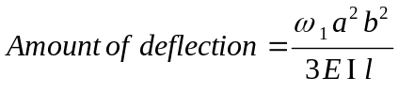 where,
a = distance between point of deflection and first support
b = distance between point of deflection and second support
ω₁ = total weight of shaft + gear at the point of deflection
l = length of shaft between supports

Gears:
Current cars use various kinds of Synchromesh units, which ensure a smooth gear change, when the vehicle is in motion. The Synchromesh unit essentially consists of blocking rings, conical sleeves and engaging dog sleeves.

The Synchomesh system is not quick enough due to the pause in the blocking ring reaction in bringing the two engaging components in phase. Most racing cars, therefore use gearbox fitted with facedog engagement system instead of a Synchromesh which provides a quicker and more responsive gear change and a closer feel for engine performance.

Design consideration for gears:

- Engine speed vs Vehicle speed graph is plotted for determining the gear ratios.
- Various important gear design parameters are calculated as follows:
- Normal tooth thickness
- Tooth thickness (at tip)
- Profile overlap
- Measurement over balls
- Span measurement over teeth etc.,

With the input parameters being
- Number of teeth
- Module
- Helix angle
- Pressure angle
- Center distance
- Required backlash
- Facewidth and
- Cutter details – addendum, dedendum, cutter tip radius, cutter tooth thickness at reference line, protuberance.

Bearings:

Bearings have to take radial and thrust loading (which is dependent on the helix angle of gear teeth) when helical gears are used. Bearings must be capable of coping with the loads that will be encountered when the transmission unit is in use. Calculations can be done by straightforward formulas.

Differential gears:

The functions of the final drive are to provide a permanent speed reduction and also to turn the drive round through 90º. A ‘differential’ essentially consists of the following parts:
- Pinion gear
- Ring gear with a differential case attached to it
- Differential pinions gears and side gears enclosed in the differential case.

Pinion and ring gears:
The pinion and ring gear can have the following tooth designs:

- Bevel gears –
a) Straight bevel
b) Spiral bevel – Teeth are curved

More quiet operation, because, curved teeth make sliding contact.It is stronger, because, more than one tooth is in contact all times.

- Hypoid gears :
In this, the centerline of the pinion shaft is below the center of the ring gear.

Advantage: It allows the drive shaft to be placed lower to permit reducing the hump on the floor.

Terms used in gear design:

- Pitch circle:
An imaginary circle, which by pure rolling action would give the same motion as the actual gear.

- Pitch circle diameter:
The diameter of the pitch circle. The size of the gear is usually specified by the pitch circle diameter. It is also called as pitch diameter.

- Pitch point:
The common point of contact between two pitch circles.

- Pitch surface:
The surface of rolling discs, which the meshing gears have replaced, at the pitch circle.
- Pressure angle or angle of obliquity:
The angle between the common normal to two gear teeth at the point of contact and the common tangent at the pitch point. It is usually denoted by φ. The standard pressure angles are 14 ½ ⁰ and 20⁰.

- Addendum:
The radial distance of a tooth from the pitch circle to the top of the tooth.

- Dedendum:
The radial distance of a tooth from the pitch circle to the bottom of the tooth.

- Addendum circle:
The circle drawn through the top of the teeth and is concentric with the pitch circle.

- Dedendum circle:
The circle drawn through the bottom of the teeth. It is also called root circle.

Root circle diameter = Pitch circle diameter x cos φ
where, φ is the pressure angle.

- Circular pitch:
The distance measured on the circumference of a pitch circle from a point on one tooth to the corresponding point on the next tooth. It is usually denoted by p_{c}. Mathematically,

Circular pitch, p_{c} = πD / T

where, D = Diameter of pitch circle T = Number of teeth on wheel

11. Diametrical pitch:
The ratio of number of teeth to the pitch circle diameter in millimeters. It is denoted by p_{d}. Mathematically,

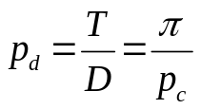 Diametrical pitch,

where, T = Number of teeth D = Pitch circle diameter

12. Module:
It is ratio of pitch circle diameter in millimeters to the number of teeth. It is usually denoted by m. Mathematically,

Module, m = D / T

- Clearance:
The radial distance from the top of the tooth to the bottom of the tooth, in a meshing gear. The circle passing through the top of the meshing gear is known as the clearance circle.

- Total depth:
The radial distance between the addendum and dedendum of a gear. It is equal to the sum of the addendum and dedendum.

- Working depth:
The radial distance from the addendum circle to the clearance circle. It is equal to the sum of the addendum of the two meshing gears.

- Tooth thickness:
The width of the tooth measured along the pitch circle.

- Tooth space:
The width of space between two adjacent teeth measured along the pitch circle.

- Backlash:
The difference between the tooth space and the tooth thickness, as measured along the pitch circle. Theoretically, the backlash should be zero, but in actual practice some backlash must be allowed to prevent jamming of teeth due to teeth errors and thermal expansion.

- Face of tooth:
The surface of the gear tooth above the pitch surface.

- Flank of tooth:
The surface of the gear tooth below the pitch surface.

- Top land:
The surface of the top of the tooth.

- Face width:
The width of the gear tooth measured parallel to its axis.

- Profile:
The curve formed by the face and the flank of the tooth.

- Fillet radius:
The radius that connects the root circle to the profile of the teeth.

- Path of contact:
The path traced by the point of contact of two teeth from the beginning to the end of engagement.

- Length of path of contact:
The length of the common normal cut-off by the addendum circles of the wheel and pinion.

- Arc of contact:
The path traced by a point on the pitch circle from the beginning to the end of engagement of a given pair of teeth. The arc contact consists of two parts, i.e.,
- Arc of approach: The portion of the path of contact from the beginning of engagement to the pitch point.
- Arc of recess: The portion of the path of contact from the pitch point to the end of engagement of a pair of teeth.

Section 4
Brake System Design

In conventional hydraulic brake systems the apply force at the brake pedal is converted to hydraulic pressure in the master cylinder. Apply force from the driver is multiplied through a mechanical advantage between the brake pedal and the master cylinder to increase the force on the master cylinder. Hydraulic pressure is a typical force transfer mechanism to the wheel brake as the fluid can be routed through flexible lines to the wheels while the wheels under complex wheel motions.

MASTER CYLINDER PRESSURE (w/o power assist):
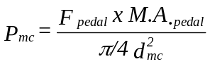
Power assist may be added to a conventional hydraulic brake system to assist the driver in brake apply. Power assist utilizes a system which may use air pressure, atmospheric/vacuum pressure hydraulic pressure or other means to apply direct force to the master cylinder.

MASTER CYLINDER PRESSURE (w/ power assist):

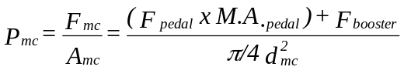
The pressure from the master cylinder is typically modified by a series of valves before reaching the wheel cylinders. The valves modify pressure to proportion pressure as a function of weight transfer, vehicle static load and load location, and the wheel brake characteristics. Valves may also be placed within these lines to provide for anti-lock braking, traction control and/or yaw stability control.

The modified master cylinder pressure is delivered to a hydraulic wheel cylinder which utilizes the hydraulic pressure to create a mechanical apply force.

WHEEL CYLINDER APPLY FORCE

The wheel cylinder mechanical force is applied to the metal backing of the friction material. The friction material, upon apply, is forced into contact with the rotating brake surface creating the friction forces required to decelerate the vehicle. The friction force from the brake friction material acts at the mean radius of the braking surface. For an internal or external expanding brake the mean radius of the braking surface is the radius of the braking surface.
For a disk brake the mean radius (r_{m}) of the braking surface is

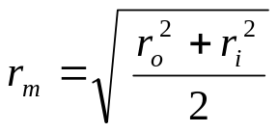 DISC BRAKE MEAN RADIUS

The wheel torque the brake system creates during braking (T_{w}) is a function of the wheel cylinder force (F_{wc}), the coefficient of friction between the friction pad and the brake surface (μ), the mean radius of the braking surface (r_{m}), the number of braking surfaces (N), and the multiplication factor (effectiveness factor) of the brake (E).

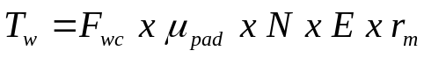 WHEEL TORQUE DURING BRAKING

N_{Disc} = 2/wheel N_{Drum} = 1/wheel

Formal calculation of brake energizing factors are derived from efficiency calculated from drive systems that employ wrap angles. In a brake system the shoes are discontinuous and the anchor pins can be located off the apply tangency point which makes calculations more complex. The equations below are those which apply to continuous wrap systems such as an external band brake. An internal shoe brake is more complex , however rough approximations can be made with these same equations.
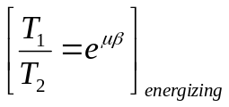 or 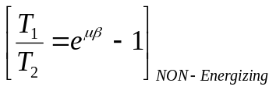

T₁ = tension on the apply side T₂ = tension on the anchor side
μ = coefficient of friction pad to surface β = wrap angle in radians

BRAKE TYPE | ENERGIZING FACTOR (approximate)
Disc | ≈ 0.7 – 0.8
Leading-Trailing drum | ≈ 2.5
Double Leading | ≈ 3.5
Dual-servo | ≈ 5.0

Brake linings all have “edge codes” for friction, compound and vendor identification. An example might be FF-20-AB. FF identifies the friction coefficient and the 20-AB identify the compound and vendor respectively. The following table identifies the coefficient of friction values. The first letter in the code provides information as to the moderate (normal) temperature characteristics, the second letter provides information as to the high temperature characteristics of the lining.

Edge Letter Code | Friction coefficient
C | μ ≤ 0.15
D | 0.15 ≤ μ ≤ 0.25
E | 0.25 ≤ μ ≤ 0.35
F | 0.35 ≤ μ ≤ 0.45
G | 0.45 ≤ μ ≤ 0.55
H | μ > 0.55
Z | unclassified

The braking force available at the tire-to-road interface is the wheel torque divided by the rolling radius of the tire.

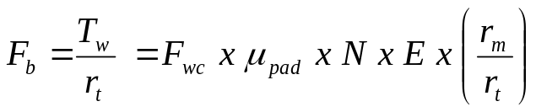 WHEEL BRAKING FORCE
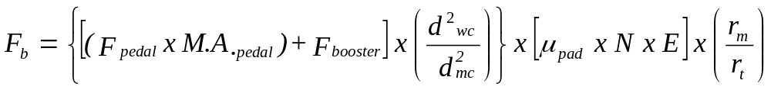

BRAKING FORCE REQUIRED FOR A STOP
The braking force required at each front wheel, if the brakes are properly propotioned, is:
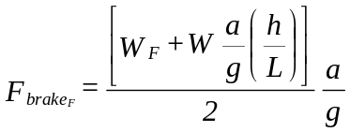

The braking force required at each rear wheel, if the brakes are properly propotioned, is:
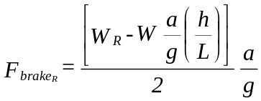

LIMITING BRAKING FORCE:
The limiting braking force over which wheel slide will occur at each front wheel is:
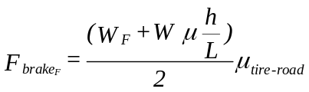
The limiting braking force over which wheel slide will occur at each rear wheel is:
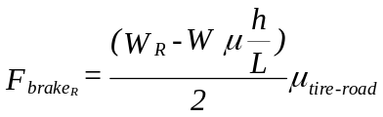

If the brakes are properly proportioned the braking force maximum is:

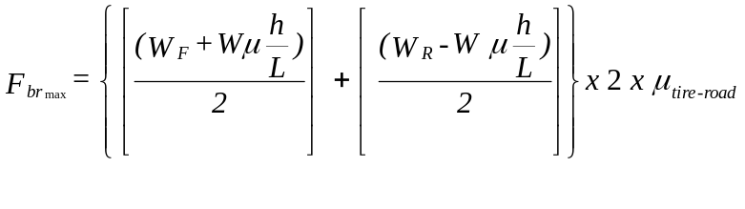

Section 4
Suspension Design Considerations

EXPERIMENTAL DETERMINATION OF THE STRUCTURAL INTEGRITY OF VEHICLES

- Vehicle stiffness is an important parameter which influences ride quality, handling properties, and vehicle aesthetics.

- Vehicle stiffness determines the quality of fit of many external panels and the interaction of the surface panels as uniform and asymmetric loads are applied.

- Road noise transmission and dynamic response is influenced by the vehicle stiffness.

- Vehicles typically are called upon to meet deflection criteria in design.
- meeting deflection criteria will establish designs that inherently meet stress related criteria.
- Chassis design will require the engineer assure that key deflection limits are imposed for critical locations on the chassis, frame and body.
- Vehicles modeled to meet crash standards may also meet deflection standards in the design process.
- All measures; deflection, stress and yield, and impact must be verified in the design process.

STIFFNESS IS MEASURED IN A NUMBER OF MODES.
- Torsional ridgidity is commonly used as measure of the overall stiffness quality.
- Fundamentally this is a measure of the deflection that occurs if all the load were place on diagonally opposite tires of the vehicle. As deflection occurs in this mode the quality of fit of the surface components on the body is altered.
- Torsion of the chassis also occurs due to the differing roll stiffness of the front and rear suspension systems.

- H-beaming is used to determine the flexural stiffness of the chassis.
- basically bending about the rocker panels of the vehicle.
- measured as flexure along the longitudinal axis of the vehicle as a vertical load is applied at specific locations along the longitudinal axis.
- Vertical deflection of the chassis is measured at critical points.
- This mode may influence glass breakage and affect ride quality.

- Cowl loading is the term used to define the stiffness as it might be viewed by the operator.

- This stiffness criteria is established such that the operator does not perceive excessive deflection of the steering column and related interior components.

- Rear end beaming is a term used to define bending due to the frame “kick-ups” that are present in rear wheel drive and dependent rear suspension vehicles.
- This is measured with the frame supported and weight added to the rear extremities of the vehicle at or near the rear bumper location.
- The measure was to assure adequate stiffness as the frame was shaped to allow clearance for rear axle movement.

- A parameter that is commonly used to establish the stiffness is the frequency of the system.
- Minimum values are always far above those anticipated in the suspension for sprung and un-sprung natural frequencies.
- This usually sets minimum values at approximately 15 Hz while most current designs will exceed 20 Hz.

- Load factors are the percentage of the maximum torsional rigidity the vehicle might see in service which is the maximum diagonal moment.

Load Factor Determination.
- Raise the vehicle and place the calibrated Zero referenced scales under each wheel. Verify the tires are properly inflated.
- Record the weight at each wheel location.
- Determine the load factor by
- taking the sum of the weights on the left and right front suspensions and multiplying the sum by ½ the wheel track.
- taking the sum of the weights on the left and right rear suspensions and multiplying the sum by ½ the wheel track.
- taking the smaller of a and b and it is to be called a load factor of one.
- Typically ¼ to ½ load factor, incrementally applied, will be used to establish the torsional rigidity for the chassis.

ANALYSIS of FRONT SUSPENSION LOADS
(FOR DESIGN)

LATERAL
{CORNERING + IMPACT}

LONGITUDINAL
{BRAKING + IMPACT} VERTICAL
{STATIC + IMPACT}

BRAKING: {use 1-2 g braking load)
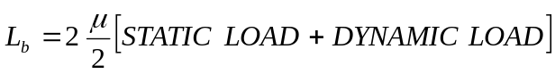
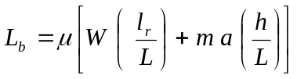

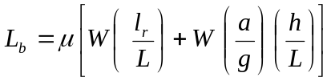

where, h = C.G Height L = Wheel base l_{r} = C.G- Rear axle

VERTICAL: {total is commonly considered as 3g load}

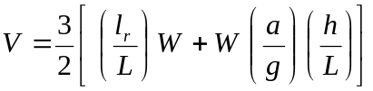

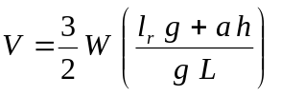

LATERAL {commonly considered as 2g load }

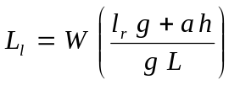

FRONT SUSPENSION LOADS

TOP VIEW:
F_{SB}
Projected Steer Axis (PSA)
d

Lateral Force (F_{LAT})
F_{UCH}
F_{L}
F_{LCH}

Upper Ball Joint to PSA (b)
Scrub Radius (r_{s})

Lower Ball Joint to PSA (c)
F_{US}

F_{LS}
_{S}
Braking Force Horizontal (B_{FH})

Σ M_{PSA} = 0

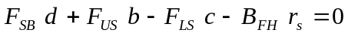

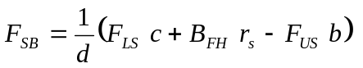

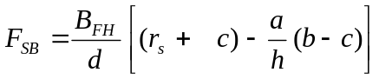

Σ F_{H-Lat} = 0

F_{UCH} + F_{SB} – F_{LCH} – F_{LAT} = 0

F_{LCH} = F_{UCH} + F_{SB} - F_{L}

Σ F_{H-Long} = 0

F_{US} – F_{LS} +B_{FH} = 0 or B_{FH} = F_{LS} - F_{US}

FRONT SUSPENSION LOADS

SIDE VIEW:

UB

F_{US}
h
SB

LB

F_{LS}
a
B_{FH}

Σ M_{B} = 0
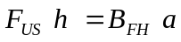

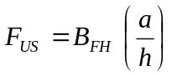
Σ F_{X} = 0
F_{US} – F_{LS} + B_{FH} = 0

F_{LS} = F_{US} + B_{FH}

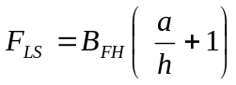

FRONT SUSPENSION LOADS

REAR VIEW:

F_{UC}
F_{UCV}
UB

α
F_{UCH}
φ

e
h
F_{SB}

F_{LCH}
LB

F_{L}
F_{LBV}

V

Σ M_{LB} = 0

F_{UCV} h tan φ + F_{UCH} h + F_{SB} e + F_{L} a – V (r_{s} + c) = 0

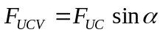
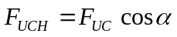

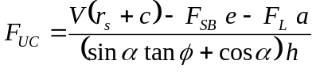

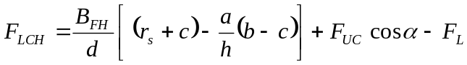

Σ F_{V} = 0
V – F_{LCV} + F_{UC} = 0
F_{LCV} = V + F_{UC} sin α

SUMMARY

F_{LCV} = V + F_{UC} sin α

UPPER CONTROL ARM

F_{UFM}

F_{ULF}
f
F_{UC}

g F_{US}

F_{ULR}

F_{URH} F_{UC}
lu

F_{UC}
Σ M_{UFP} = 0
F_{UC} (f) + F_{US} (lu) – F_{ULR}(f+g) = 0
F_{ULR} = F_{UC} (f) + F_{US} (lu) {In the direction of F_{UC}}
f+g
Σ F_{AXIS} = 0
F_{ULF} + F_{ULR} = F_{UC}
F_{ULF} = F_{UC} - F_{ULR}
To determine F_{UFH} and F_{URH} the geometry and the understanding that all loads pass through UB can be used:

g/ lu = F_{URH} / F_{ULR}
∴ F_{URH} = F_{ULR} (g)
lu

F_{UFH} + F_{URH} = F_{US}
F_{UFH} = F_{US} – F_{URH}

LOWER CONTROL ARM

{Spring force and bump stop force need be determined}

F_{LS}

i
F_{LC}

j

F_{B} F_{LCV}
F_{SP}
l_{b}
l_{s} F_{LCH}

β l_{l}

LOGARITHMIC DECREMENT

Logarithmic decrement can be used to experimentally determine the amount of damping present in a free vibrating system.

For damped vibration the displacement (x) is expressed as equation 1.
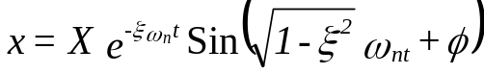
The logarithmic decrement is then defined as the natural log or the ratio of any two successive amplitudes as shown in equation 2.
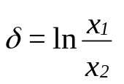

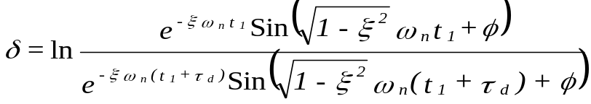

Equation 2 can be reduced to equation 3 based on the fact that the value of the sines are equal for each period at t = t1+τ_{d}.
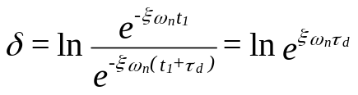

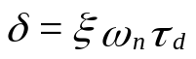

Since the damped period is
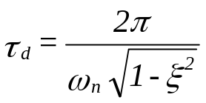

equation 3 can be reduced to equation 5.

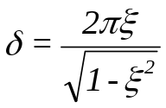

Therefore the amplitude ratio for any two consecutive cycles is as shown in equation 6.
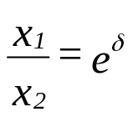

It can also be show that for n cycles the following relationship exists
